# **My Password Bookie Documentation**

## **Languages used:**

**Html, CSS and JavaScript (jQuery).**

## **Database:**

**Firebase database**

1. **Cloud Firestore (For data storage)**
2. **Authentication (For authentication)**
3. **Firebase hosting (For hosting of web admin panel).**

## **Firebase configuration:**

Firebase configuration is done in **firebase.js** file and it is located in **/public/app-assets/js/auth-login.js**.

From **line number 8 to 15** this code is for configuration of firebase in the project.  
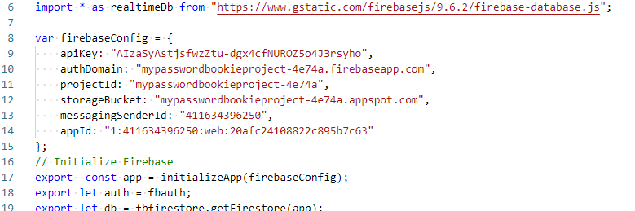

## **Folder structure:**

1. **Account:** All the CSS and JavaScript files that are used in login, signup and forget password page are present in this folder. Subfolders that are present in this folder are: 1) CSS: It contains all the style sheets.  
    2) Js: It contains all the JavaScript files.
2. **app-assets:** All the CSS and JavaScript files that are used in passwords, my profile pages are present in this folder. Subfolders that are present in this folder are:  
    1) CSS: It contains all the style sheets  
    2) Js: It contains all the JavaScript files. (the explanation will be discussed in the next section).  
    3) Fonts: It contain a single file in CSS folder which contain a file font-awesome.min.css.  
    4) pwd_strength: It contains CSS and JavaScript file that we are using in password analyzer page to check password strength (will be discussed in the next section).   
    5) vendors: It is a bootstrap folder that contain all necessary files to show website design.
3. **Fonts:** font awesome plugin fonts that we are using in this web admin panel.
4. **Html Pages:**

* **404.html:**Default firebase error page that we are going to show if there is some error in our application or any link is not found.
* **auth_login.html:**This is the login page of the application. It mainly uses one JavaScript file for functionality which is: **auth-login.js**: Location of file **/public/app-assets/js/auth-login.js**.  
  When we submit request from login page then request is validate in this JavaScript file.  
  **Validation is done in this section.**

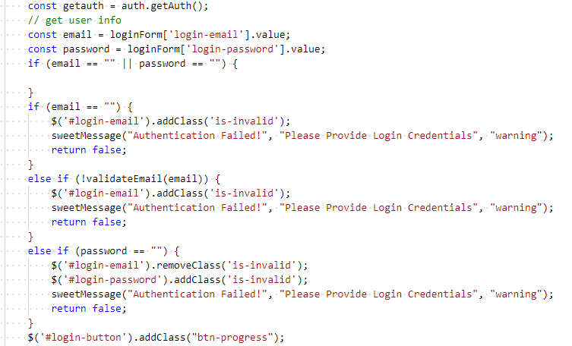

**Sign request is send in this section to firebase to check login email and password.**

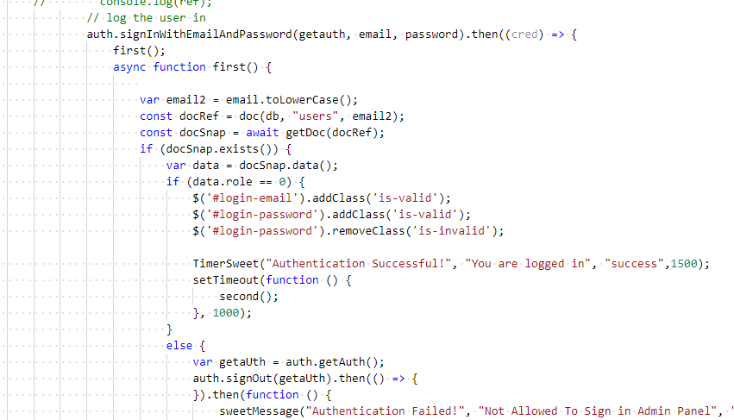

* **auth_signup.html:**This is the signup page of the application. It mainly uses one JavaScript file for functionality which is: **auth-signup.js**: Location of file **/public/app-assets/js/auth-signup.js**.  
  When we submit request from signup page then request is validate in this JavaScript file.  
  **This is the section where create new user and add his data cloud firestore.** 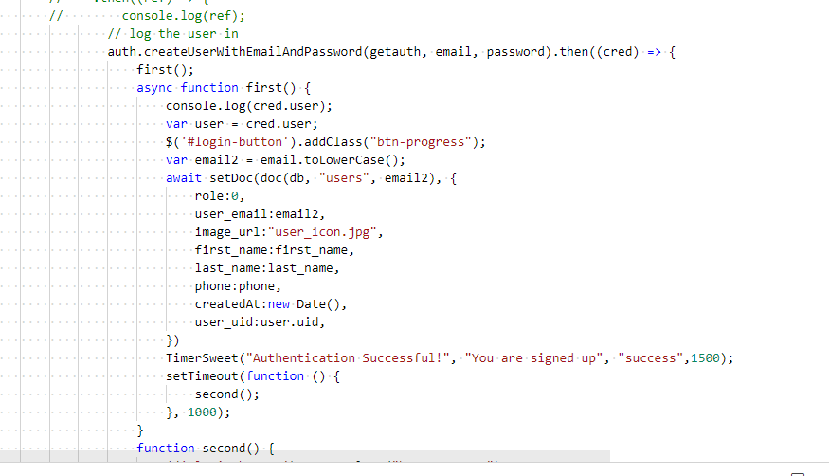
* **forgot-password.html:**This is the forgot password page of the application. It mainly uses one JavaScript file for functionality which is: **forgotpassword.js**: Location of file **/public/app-assets/js/** **forgotpassword.js**.  
  When we submit request from forgot password page then request is validate in this JavaScript file.  
  **This is the section forgot password request is sent to firebase using sendPasswordResetEmail function.  
  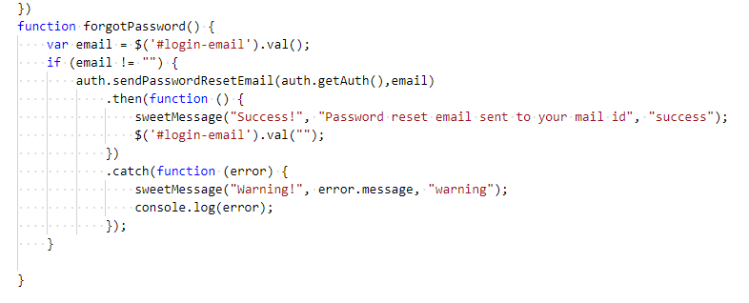**
* **Logout:**For logging user out we are using **logout.js** (Location of file **/public/app-assets/js/logout.js**.)  
  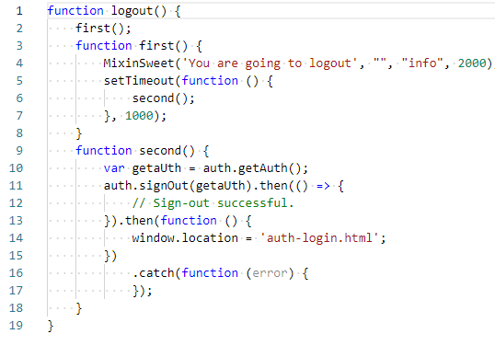
* **myprofile.html:**This is my profile page of the application. It uses **auth-check.js** to check if user is logged in or not (Location of file **/public/app-assets/js/auth-check.js**.). It mainly uses one JavaScript file for functionality which is: **myprofile.js**: Location of file **/public/app-assets/js/** **myprofile.js**.  
  Edit profile and change password is done in this file.  
  **This is the form submit function of edit profile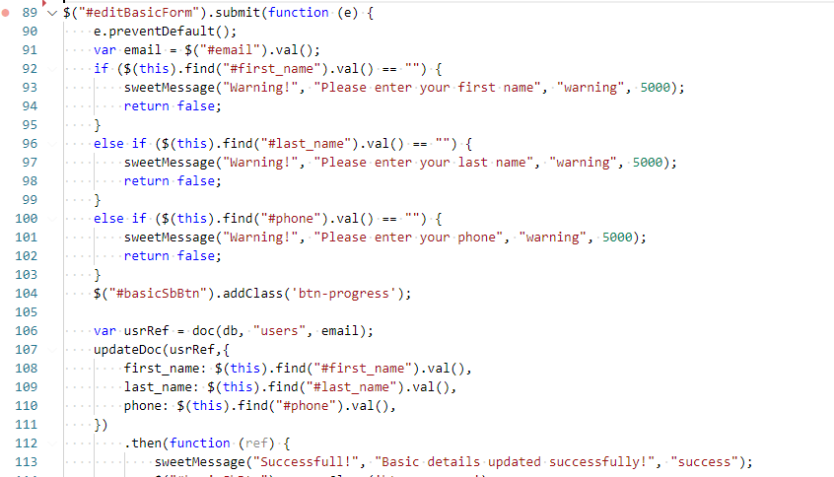 This is the form submit function of change password.  
  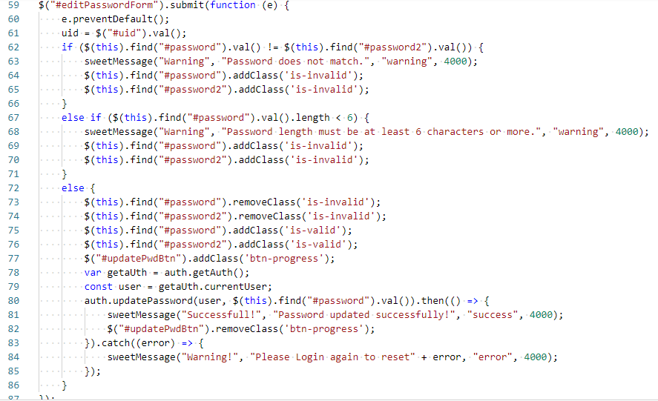**
* **passwords.html:**This is my passwords page of the application where users can see all passwords that he has added. It uses **auth-check.js** to check if user is logged in or not (Location of file **/public/app-assets/js/auth-check.js**.). It mainly uses one JavaScript file for functionality which is: **passwords.js**: Location of file **/public/app-assets/js/passwords.js**.  
  This is file where we manage all passwords and run password analyzer function and password generator function.  
  **This is the section where data is get from firebase and table is created. Function requires parameter name email which will the current user email.  
  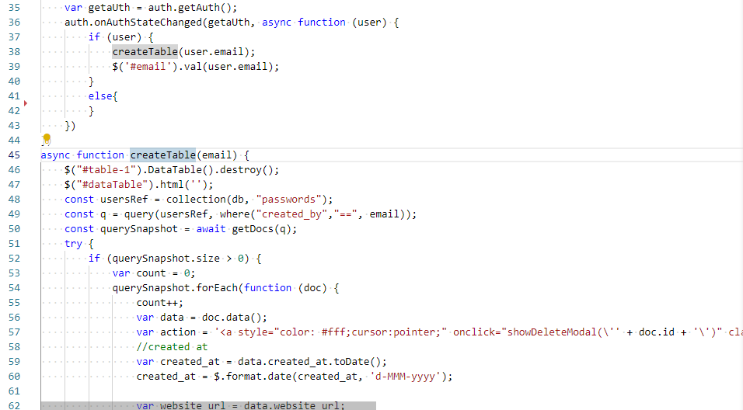**

**These two functions are for deleting passwords. If you click yes on pop-up it will call deleteEntity function which will delete the password.  
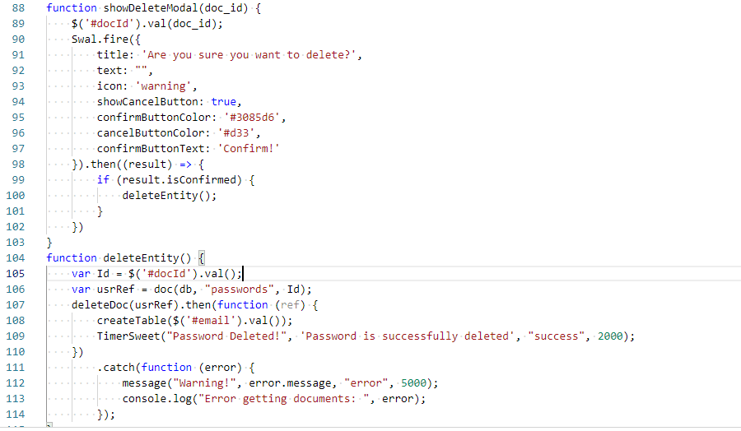**

**These two functions are for adding passwords. The first one will be open the modal and second one will save the details that are filled in the pop-up modal.**  
  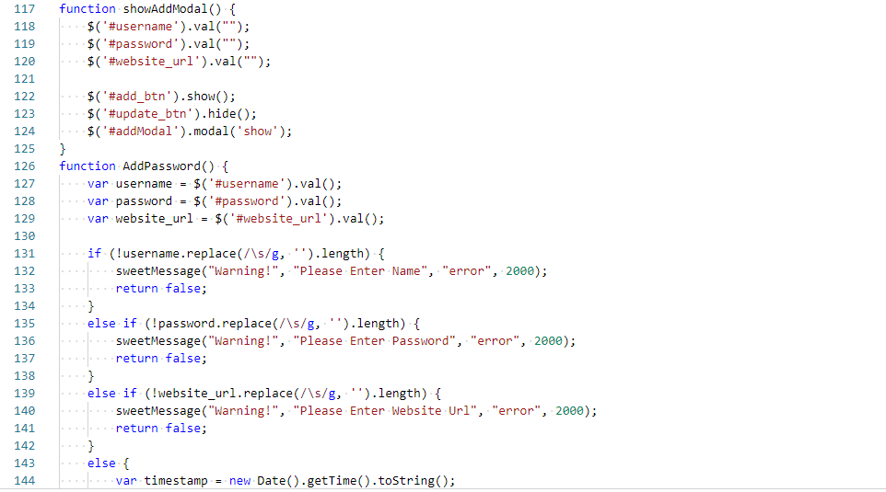  
 **These two functions are for updating passwords details.   
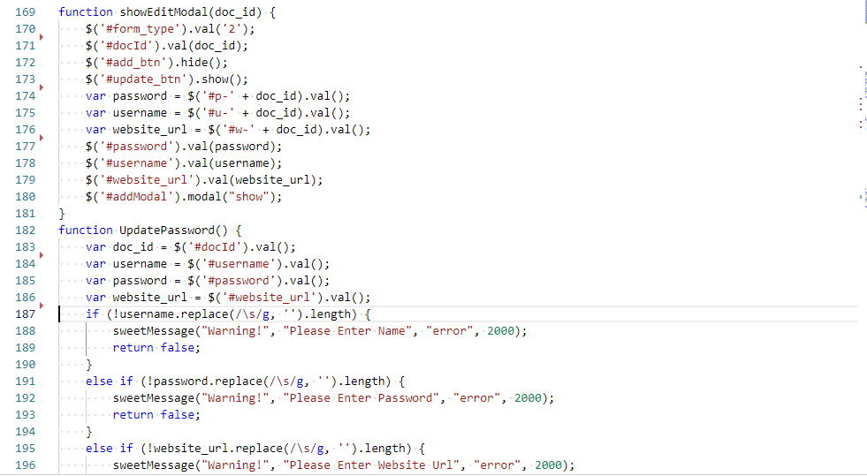**

**These is to open the password analyzer modal. The main files that we are using for password analyzing are saved in app-assets/pwd_strength folder.  
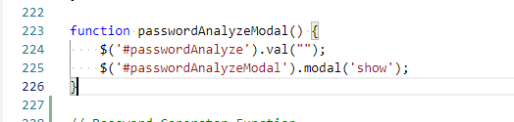**

**These are functions to generate passwords   
